A small project for Coupon System web application.

**Admin Username:**

admin@admin

**Admin Password:**

admin

The system support 3 different users -  
Admin, Company & Customer - The login method fetch the data from the DB  
and each of the users attempt to login get's different response.  
After login every user gets is own Methods, Logics, Data and Session.

This is the list of the db

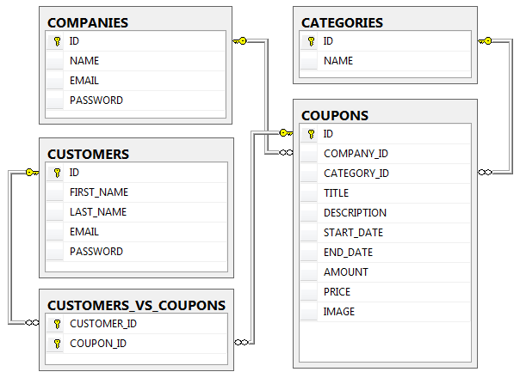

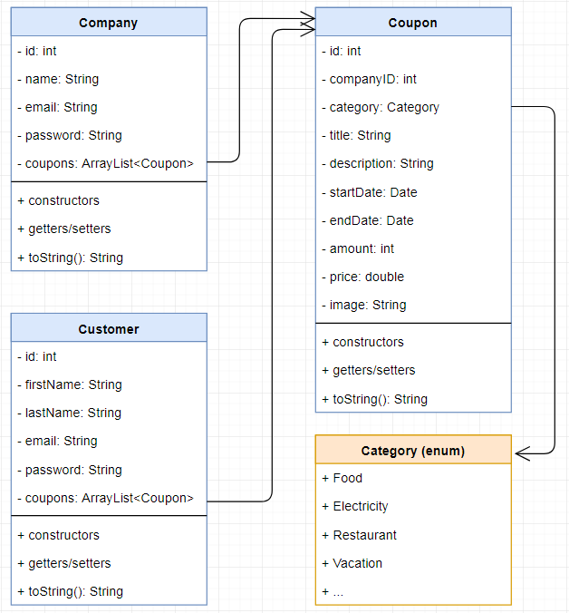

**Admin - Has a panel to manage all customers, companies & coupons.**

**Can’t add user with an existing name or email and the same as in the company**

**Can’t edit name/email user/company to an existing one**

**admin can edit/ delete add users- and see the completely users list .**

**admin can edit/ delete add companies- and see the completely companies list .**

**Company - Can add Coupons as much as they like as advertising campaign & they have a panel to manage those coupons.- edit/delete**

**And see whose customer purchase specific coupons,**

**if company need to delete coupon. It should delete from the user list coupon too, no logic that user still purchase an deleted coupon.**

**If coupon is expired of date, the app will delete it ,, no logic to purchase an expired coupon**

**Customer - Can search & buy coupons, and use them.**

**If customer buy specific coupon . the amount of the coupon will less by 1**

**And of the amount of it is 0 so the app will not let hem to buy it ..**

**When the app is running. Should run an function that deleted all the expired coupon automatically**

For the of the entities should handle from the frontend – this func.

